# What is Scrum?

Scrum is a management framework that teams use to self-organize and work towards a common goal.

The purpose of Scrum is to allow teams to self-manage, learn from experience and adapt to change.

It describes a set of meetings, tools and roles for efficient project delivery.

# Trello:

Trello is a website that allows for segmented development for a team. There is one board for a project that an entire team can change and plan using. Individual team members can move sections of the project into the different columns to denote what stage of progress it is in.

# Scrum and Trello and how they work together:

Scrum is a kind of project management for teams that uses iterative development. It divides the project into small manageable pieces called “sprint”. Trello is a service that allows you to have a team board and different columns. These columns are typically broken up into the different stages of development for the different parts of the project. For example, You can have a different columns named “To-do”, “in progress”, and “Done”. You can freely move each section of the project into the different columns to identify it’s stage of development.

https://www.scrum.org/resources/what-scrum-module

# What is ASCII?

ASCII otherwise known as the American Standard Code for Information Interchange, is a character encoding standard for communication. ASCII codes represent the texts in computers. Newer computer systems use Unicode which includes the ASCII set alongside millions of other code points.

# What are AWS?

AWS (Amazon Web Services) manages the infrastructure all the way to the hypervisor, everything above that is the responsibility of the developer i.e., managing guest operating system, MySQL engine or the data in it. It offers and provides on-demand cloud computing platforms and APIs to individuals, companies and governments.

# What was the original name of Mickey Mouse?

Searched: mickey mouse +original name

Answer: Walt Disney named his first iteration of the character Mortimer Mouse. However, at the urging of Lillian Disney, his wife, the character was renamed Mickey Mouse; reportedly, Lillian disliked the name Mortimer for the mouse and suggested Mickey.

# What is the current time in St. John’s, NL and Sydney, Australia?

Searched: time st.johns + time sydney Australia

Answer: 9:55 a.m. Monday, in St. John's, NL is

10:25 p.m. Monday, in Sydney NSW, Australia

# What is the depth of the Dead Sea?

Searched: dead sea +depth

# Who invented the Safety Pin? List other things he invented.

Searched: inventor safety pin +list inventions

Answer: Sewing Machine and Safety Pin

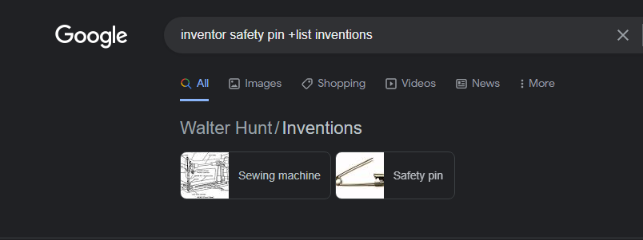

# What does a Praying Mantis do after mating?

Searched: praying mantis +after mating

Answer:

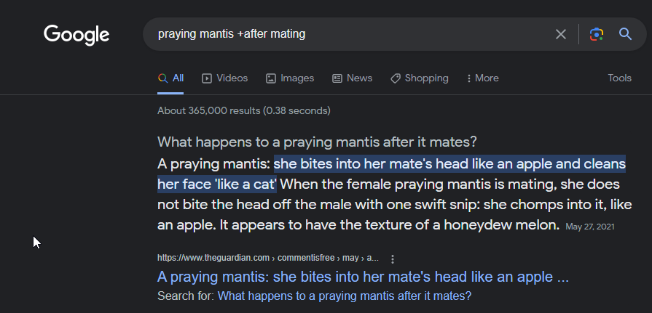

What is the provincial bird, flower, and tree of NL?

Searched: Newfoundland provincial bird, flower, and tree

Answer: The provincial bird, flower and tree of Newfoundland is the Puffin, Purple pitcher plant, and Black spruce tree.

What are the capitals of Mongolia and Croatia?

Searched: Capital of Mongolia + Croatia

Answer: The capital of Mongolia is Ulaanbaatar and the Capital of Croatia is Zagreb

List 3 movies that starred Will Smith.

Searched: Will Smith + Movies

Answer: 3 movies that star Will Smith are Emancipation, Hancock and After Earth

# Aseptic Techniques

Aseptic techniques are a set of practices that protect patients from infections they could get from healthcare and also protect healthcare workers from contact with blood, body fluids and body tissue. There are four aspects of the aseptic technique: barriers, patient equipment and preparation, environmental controls, and contact guidelines. Barriers include things such as sterile gloves and gowns, masks for both the patient and the healthcare workers, as well as drapes. Patient and equipment preparation include using sterile equipment and instruments, as well as sterilizing the patient’s skin. Environmental controls include keeping doors closed during operations, and only having necessary healthcare workers present in the room. Contact guidelines are simple rules that healthcare providers must follow such as only touching sterile items – often these guidelines encompass the previous aspects.

Sources:

<https://www.safetyandquality.gov.au/our-work/infection-prevention-and-control/aseptic-technique>

<https://www.healthline.com/health/aseptic-technique#aseptic-vs-clean>

# Self Care

Self-Care is defined as “the ability of individuals, families and communities to promote health, prevent disease, maintain health and cope with illness and disability with or without the support of a health worker” by the World Health Organization. Essentially it is everything that is required for a person to stay healthy, including things such as hygiene, nutrition, and going to the doctor when needed. All in all, it is the act of taking care of yourself and not only adopting healthy lifestyle habits, but also avoiding unhealthy lifestyle habits. Self-care allows for a person to be more in tune with their body, if you are consciously making sure your body is in good condition, it is easier to feel when something is going wrong and make an appropriate decision through by self-monitoring and self-management.

Sources:

<https://www.selfcarefederation.org/what-is-self-care>

<https://www.everydayhealth.com/self-care/>

* Employment Equity:

Employment Equity is a policy where staff or team members will represent different segments of the population, including women, minorities, and people with mental and physical difficulties.

QAP – 3

**Searches:**

* In what year(s) was Cabot Tower built? What was done with the surplus bricks/stone?

Search 1: What year was the Cabot Tower built?

Result 1: Cabot Tower began construction in 1897 and finished in 1900.

Search 2: Cabot Tower surplus stone.

Result 2: The surplus stone from the Cabot Tower were used to construct the Temperance Street Houses.

* Where did the tradition of the Christmas tree come from?

Search: Christmas Tree tradition origin.

Result: The tradition of the Christmas Tree is credited to Germany in the 16th century.

